Weedstock In The Hills ’23 - LP Vendor Information

Event Date: July 21st 2023 – July 23rd 2023

420Events would like to invite you to be apart of bringing the first ever cannabis-based Music Festival & Tradeshow to Saskatchewan this summer! Situated in an area between Saskatoon and Regina known lovingly by the locals as Little Bear Hills, this private, rustic and secluded gem of the prairies has been setup to accommodate everything we need to enjoy a fun-filled and completely compliant weekend full of good music & camping, all while immersing ourselves in the cannabis culture of the prairies!

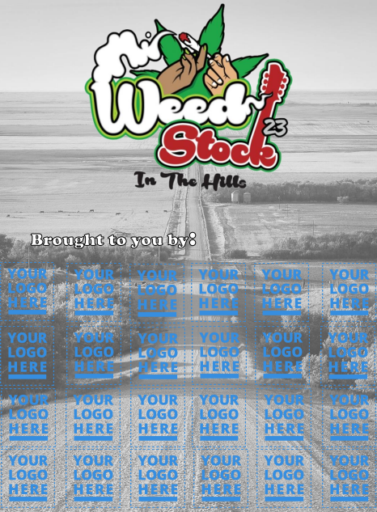
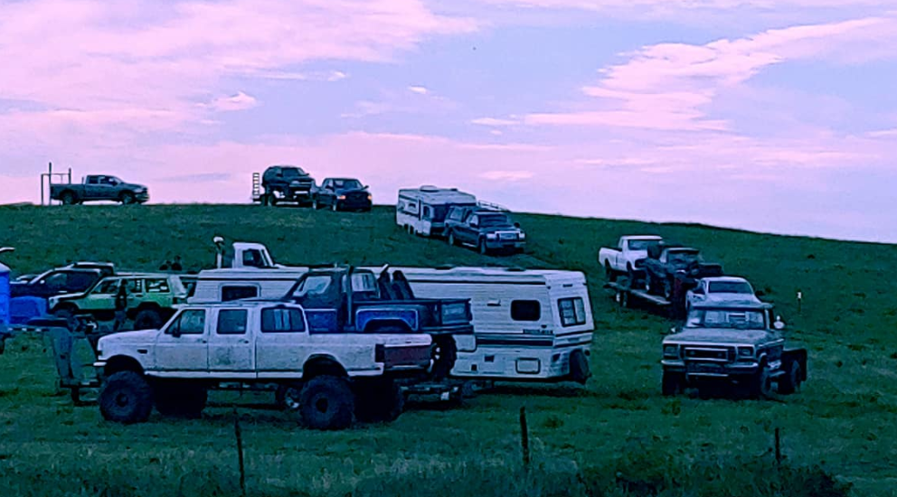

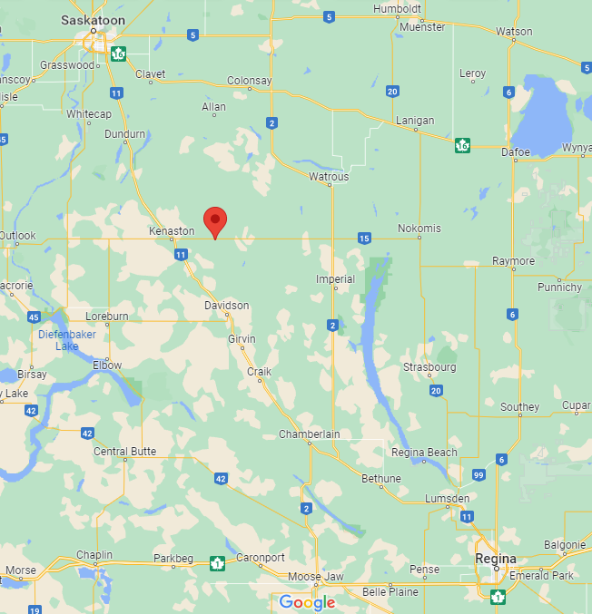

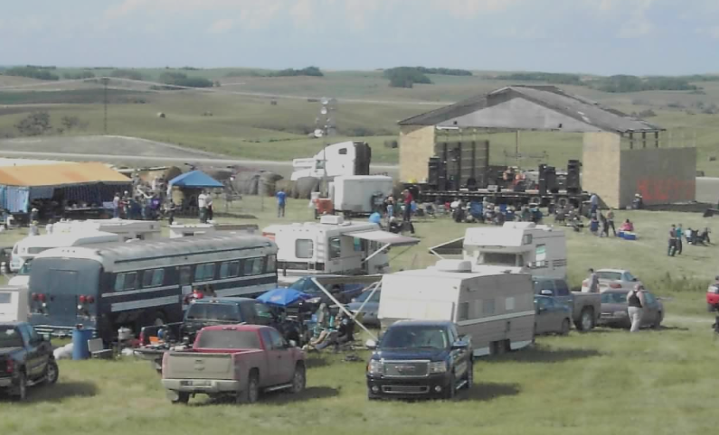

NOTE: This is a 19+ event that is open to the public
*Stores and other industry folks will be given a 50% code for Eventbrite*
Tickets & IDs will be checked at the entrance & people who present their discounted tickets will also be required to show a photo of their Cannasell

Pricing: $500.00 /brand
Due: June 20th, 2023

Sponsorship includes:

-Ticketless entry to the entire festival for your team (up to 3 reps/volunteers per brand)

-Your logo on our fliers, banner, website & social media

-A table (supplied) to set up for an entire afternoon on Saturday

-The ability to hand out swag & sample products

-The opportunity to get in front of and interact with hundreds of consumers to showcase and educate about your products

*See Event Schedule for further information*

Fund Disclaimer:
All monies collected by sponsors will go directly towards the cost of equipment rentals, supplies, and entertainment – an invoice for your contribution will be supplied.

Please send via EMT by June 20th, 2023 to: miranda@420events.org

Directions: https://goo.gl/maps/fV6Sdtj2KZiA4qBB7

www.weedstock.ca
example
example

